Techno Machine Tools

Survey no:126/A/1, DOOR NO: 4-132-9/A/2, Gandimaisamma X Road,

Medchal Malkajgeri,Hyderabad-500043.Telangana, India.

(Mfg of shearing machines and press brakes)

T.SIVARAMAKRISHNA
ME., MBA.

TMT/SF Traders/S034/2015 24.01.2025

To,
Mr Abdul Razak,
SF Traders,
Mobile +919965747887,
Email : alfadieing@gmail.com, city Namakkal,
State : Tamil Nadu.

Dear Sirs,

Sub :- Supply of HYDRAULIC PRESS BRAKE MACHINE.

Thank you very much for your enquiry regarding your requirement of hydraulic press brake. We are glad to inform you that we would be in a position to supply you the required equipment. Given below are the required specifications and description of the machine along with our terms and conditions.

PRESS BRAKE :

1) Size : 4,000 X 10 mm

2) Tonnage : 320 M.T.

S No | Description of the unit | Offer
1. | Hydraulic Press Brake with bending capacity 4.0 Meters and 10.0 mm MS Sheet, 400 MT load capacity with Power pack of 25 HP motor along with one set Standard Die and Punch | Rs 23,50,000/-  (Rupees Twenty Three Lakhs Fifty Thousand Only)

SPECIFICATIONS FOR THE HYDRAULIC PRESS BRAKE MACHINE WITH 4000 M.M. WIDTH AND 10. M.M. THICKNES.

1. Tonnage : 320 Ton

2. Clearance between Housings : 3500 M.M.

3. Bending capacity in M.S. : 4000 x 10 M.M.

4. Ram stroke. : 150 M.M.

5. Open height. : 350 M.M.

6. Closed height. : 200 M.M.

7. Depth of Throat. : 300 M.M.

- Ram speeds.

a) Approach. : 20 M.M. per Sec.

b) Pressing. : 5 M.M. per Sec.

c) Return. : 35 M.M. per Sec.

9. Motor capacity. : 7.5 H.P. (Crompton)

10. Punch. :4000 x 160 x 45 M.M.
( ‘GROOSE NECK’ type)

11. Bed size. : 4000 x 250 x 65 M.M.

12. Cost of Machine. : Rs. 23,50,000/- + Taxes.

13. Mode of payment. : As per the quotation.

14. Delivery. : As per the quotation.

15. Back Guage : Manual

For Techno Machine Tools

( T. Sivaramakrishna)

GENERAL TERMS & CONDITIONS:

- Price quoted per unit ex-work. Hyderabad.
- Following charges are additional to your account.
- Freight Charge : As actual to be borne by you.
- Excise duty : Extra As Applicable
- Sales Tax : Extra as applicable
- Packing charge : Actual to be borne by you.
- Insurance : Actual to be borne by you.
- Payment : 50% advance along with order balance before delivery but after inspection at our works.
- Delivery : With 50% advance within 3 months.
- Validity : One month from the date of submission.
- Inspection : Inspection at our works prior to dispatch.
- Warranty : The machine is warranted for a period of 12 months from the date of dispatch against any manufacturing defects/ faulty material or bad workmanship of any part or component but not against any kind of abnormal or improper use of machine. Defective part or component will be replaced or repaired free of cost. Electrical components are outside the scope of this warranty.
- Commissioning : Cost of Erection & commissioning to be borne by you, but required technical support & guidance will be provided by us at additional cost.

NOTE:
- Oil is not in scope of our supply.
- Raw material for trial is to be arranged by you at your cost.

We are sure you will find our offer in line with your requirements. Should you require any further clarification please contact on mob:9246221106 for further submission and clarification.
Thanking you and assuring you of our best services at all times.

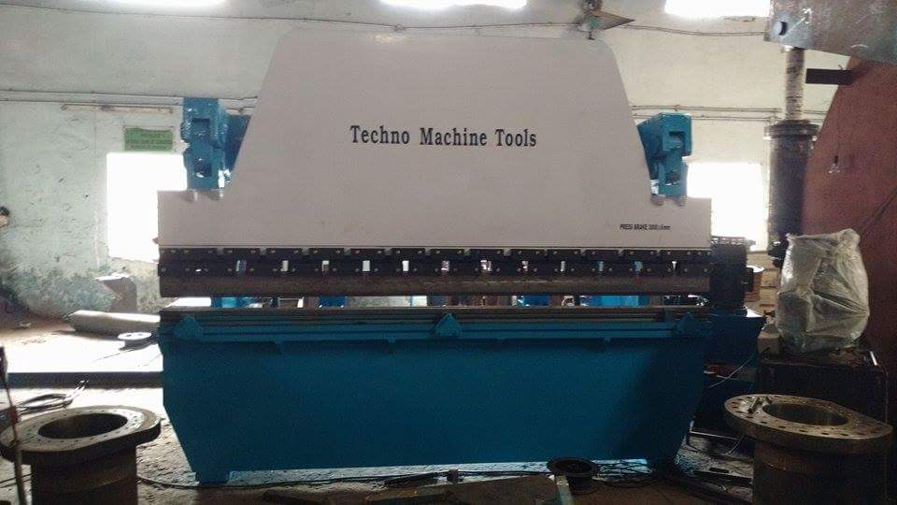

For Techno Machine Tools

( T. Sivaramakrishna)

